Research on Real-Time Environmental Parameters Display
Author¹, Author²
Bachelor of Engineering, Electronics and Telecommunication, Jawaharlal Darda Institute of Engineering and Technology, Yavatmal

Abstract— Air pollution refers to the release of pollutants into the air—pollutants which are harmful to human health and the planet as a whole, such as Carbon Monoxide(CO), Methane, Nitrous Oxide, Carbon Dioxide (CO2), Fluorinated gases(F-gases), which as a whole affect the climatic changes. As the issue becomes more dominant, it is constantly required to monitor these harmful gases and take necessary actions to eradicate this issue. This system presents the idea of detecting harmful gases in the environment and providing the data to an administrator. The main aim of this system is to achieve pollutant monitoring using wireless sensors connected to the Internet, which send the measurements to a centralised server. Low-power sensors are used to detect the parameters and interact with the microcontroller to process the data. The ultimate goal of this system is to detect harmful gases and monitor the conditions. In this paper, we aim to build a system that can fetch the values of harmful pollutants present in that location and raise an alarm whenever the levels are breached, so that we can effectively monitor the changes and take necessary actions to normalise the pollutant levels

Keywords -Pollutant monitoring, Harmful gases, Wireless sensor.

- INTRODUCTION

Air pollution is the biggest problem of every nation, whether it is developed or developing. Health problems have been growing at a faster rate especially in urban areas of developing countries where industrialization and growing number of vehicles leads to release of a lot of gaseous pollutants. Harmful effects of pollution include mild allergic reactions such as irritation of the throat, eyes and nose as well as some serious problems like bronchitis, heart diseases, pneumonia, lung and aggravated asthma. According to a survey, due to air pollution 50,000 to 100,000 premature deaths per year occur in the U.S. alone. Whereas the EU number reaches 300,000 and over 3,000,000 worldwide. Here to make an Air Pollution Monitoring System in which we will monitor the air quality and will trigger an alarm when the air quality goes down beyond a certain level, meaning when there are sufficient amounts of harmful gases present in the air like CO2, smoke, alcohol, benzene and NH3. It will show the air quality in PPM on the 4 bits LED so that we can monitor it very easily. MQ2 sensor which is the best choice for monitoring Air Quality as it can detect most harmful gases and can measure their amount accurately. When pollution goes beyond some level, it triggers an alert through a buzzer.

II. LITERATURE REVIEW
1. M. DEEPSHIKA et al. studies commonly utilize embedded systems and IoT-based platforms with microcontrollers such as Arduino and ESP modules integrated with MQ series gas sensors to detect harmful gases like CO₂, CO, and other air pollutants. Temperature and humidity sensors such as DHT11 are often incorporated to analyze environmental conditions influencing air quality. Many proposed systems include threshold-based alert mechanisms using buzzers, LEDs, or mobile notifications to warn users when pollution levels exceed safe limits. Recent advancements emphasize cloud connectivity for data logging and remote visualization through web or mobile applications. These studies demonstrate that real-time monitoring systems provide a cost-effective, reliable, and efficient solution for continuous environmental surveillance, forming a strong foundation for the proposed system.
2. Thanushree D. and Vaishnavi G. presented an air quality detection system using embedded technology aimed at monitoring environmental pollution in real time. Their work focuses on the integration of a microcontroller-based system with gas sensors from the MQ series to detect harmful air pollutants and assess air quality levels effectively. The system continuously monitors parameters such as gas concentration and environmental conditions, providing timely feedback through display or alert mechanisms. The study highlights the advantages of using embedded systems for air quality monitoring due to their low cost, simplicity, and real-time response capability. This research demonstrates the practicality of embedded solutions in environmental monitoring applications and contributes to the development of efficient air quality detection systems for indoor and outdoor environments.
3. Yeshvant B.A. presented a real-time temperature and humidity monitoring system using embedded system technology to continuously observe environmental conditions. The proposed system integrates a microcontroller with temperature and humidity sensors such as DHT series sensors, enabling accurate and real-time data acquisition. The monitored parameters are displayed instantly, allowing users to track changes in environmental conditions efficiently. The study emphasizes the importance of real-time monitoring in applications such as indoor climate control, agriculture, and industrial environments. By utilizing a low-cost embedded platform, the system demonstrates a reliable, economical, and user-friendly solution for continuous temperature and humidity monitoring.
4. Fatima Khan proposed an IoT-driven pollution detection system designed to monitor air quality in both indoor and outdoor environments using smart sensing and internet connectivity. The system integrates various environmental sensors to measure pollution parameters and transmits the collected data to an IoT platform for real-time monitoring and analysis. By leveraging IoT technology, the system enables remote access, continuous data logging, and timely alerts when pollution levels exceed permissible limits. The study highlights the effectiveness of IoT-based solutions in improving environmental awareness, enhancing decision-making, and providing scalable, low-cost monitoring for smart homes, cities, and industrial areas. This work demonstrates how IoT significantly enhances traditional pollution monitoring systems through real-time visibility and connectivity.
5. Osama Alsamrai proposed a real-time intelligent air quality monitoring system for urban environments by combining IoT sensing technology with machine learning algorithms. The system collects air pollution data from multiple sensors and transmits it to a cloud-based platform for real-time analysis and visualization. Machine learning models are used to predict pollution trends, detect anomalies, and provide actionable insights, enhancing decision-making for environmental management. The study demonstrates that integrating IoT with predictive analytics can significantly improve air quality monitoring by providing timely alerts, long-term trend analysis, and data-driven recommendations for mitigating urban pollution. This work highlights the potential of intelligent, connected systems in building smarter and healthier cities.
6. Tanishq Kale proposed a real-time industrial pollution monitoring system that utilizes IoT-enabled sensors to continuously measure air quality parameters such as harmful gas concentrations, particulate matter, and environmental conditions in industrial settings. The system transmits collected data to a cloud platform, enabling remote monitoring, real-time visualization, and data logging. Alerts are generated automatically when pollutant levels exceed safe thresholds, allowing timely intervention to reduce environmental and health risks. The study highlights the effectiveness of IoT-based solutions for industrial environmental management, providing a low-cost, scalable, and automated approach for continuous pollution monitoring and regulatory compliance.
7. Manuel Méndez presented a comprehensive survey on machine learning algorithms for air quality forecasting, highlighting how predictive models can improve the accuracy and efficiency of environmental monitoring systems. The study reviews techniques such as regression models, neural networks, and ensemble learning methods for predicting pollution levels based on historical sensor data. These machine learning approaches enable proactive measures by anticipating high pollution events, optimizing resource allocation, and generating timely alerts. The survey emphasizes the integration of IoT-collected data with predictive algorithms to create smart and intelligent air quality monitoring systems, demonstrating the potential of combining real-time sensing with data-driven analytics for urban, industrial, and environmental management applications.
8. Darshini Rajasekar proposed an IoT-based air quality monitoring system integrated with machine learning algorithms to not only track environmental pollution but also predict potential health impacts. The system collects real-time data on air pollutants such as CO₂, CO, and particulate matter using connected sensors and transmits it to a cloud platform for analysis. Machine learning models are applied to correlate pollution levels with health risks, enabling disease prediction and early warnings for respiratory and other pollution-related conditions. This approach demonstrates the benefits of combining IoT-enabled sensing with predictive analytics to provide timely alerts, improve public health awareness, and facilitate proactive measures for mitigating the effects of poor air quality.
9. J. Prayudha, et al. researchers created a system that can measure air quality by combining the IoT concept and the fuzzy intelligence method in their research using Arduino Uno. The results of this study are more accurate than conventional measurements, but, in this study, the speed of the internet greatly affects the web-based server in making changes to the latest information (updates), so it requires an internet service that has optimal speed, as well as sufficient device server support. This paper does not specify any specific sensor, and only focuses on fuzzy logic implementation.
10. N. Middinali et al. proposed module is used as a sensor that works to monitor air quality. The application will process data in the form of numbers which are sent to the MySQL database to be uploaded to the internet network in accordance with the ISPU (Air Pollution Standard Index) for further display on the website. This research only monitors the presence of PM10, O3, and CO in the air using MiCS2610

III. METHODOLOGY

The proposed system is designed to provide real-time monitoring of environmental parameters using an embedded system platform. It is based on the ESP32 microcontroller, which serves as the central controller for processing sensor data and controlling alert mechanisms. The system integrates an MQ2 sensor to detect CO₂ levels and dust particles, providing an accurate measure of air quality. Additionally, a DHT11 sensor is used to monitor temperature and humidity, giving a complete view of environmental conditions.

All sensor data is continuously read and processed by the controller. To enhance user interaction, a 4 bits LED display is added to show real-time values of parameters such as temperature, humidity, and air quality levels. This allows users to easily view the readings directly on the device. When any parameter exceeds its predefined threshold, the system immediately triggers a buzzer alert while also displaying the warning values on the LED display, notifying users of unsafe conditions.

The proposed system is portable, cost-effective, and easy to deploy, making it suitable for indoor environments, offices, classrooms, or industrial settings where monitoring air quality is crucial. By combining multiple sensors, a LED display, and real-time alerts, the system ensures timely awareness and helps in maintaining a safe and healthy environment.

BLOCK DIAGRAM

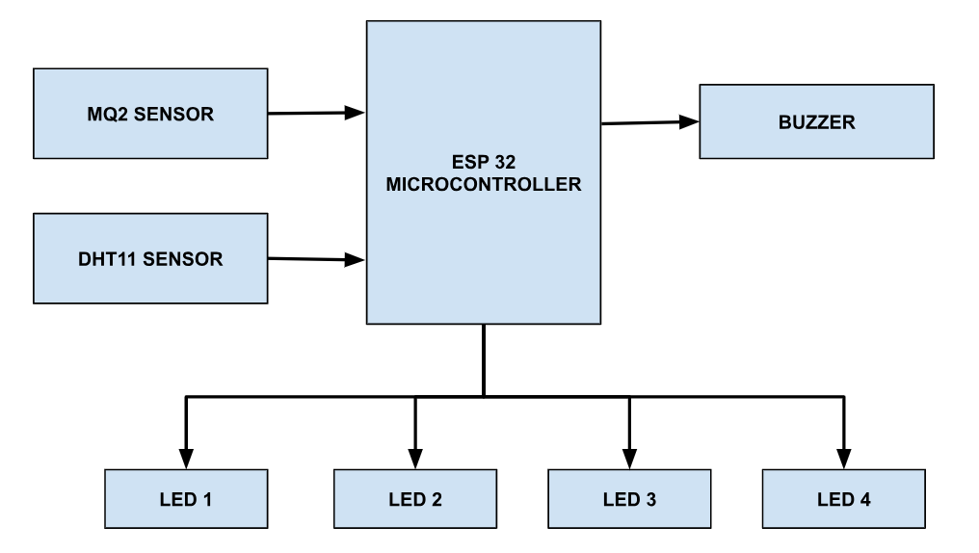

Fig 1. Shows the block diagram of the system

DESCRIPTION

In this block daigram we have used an ESP32 Microcontroller, In input we have MQ2 Sensor and DHT11 Sensor. In output we have four 4 bit LED displays and buzzer for alert generation.

FLOW CHART

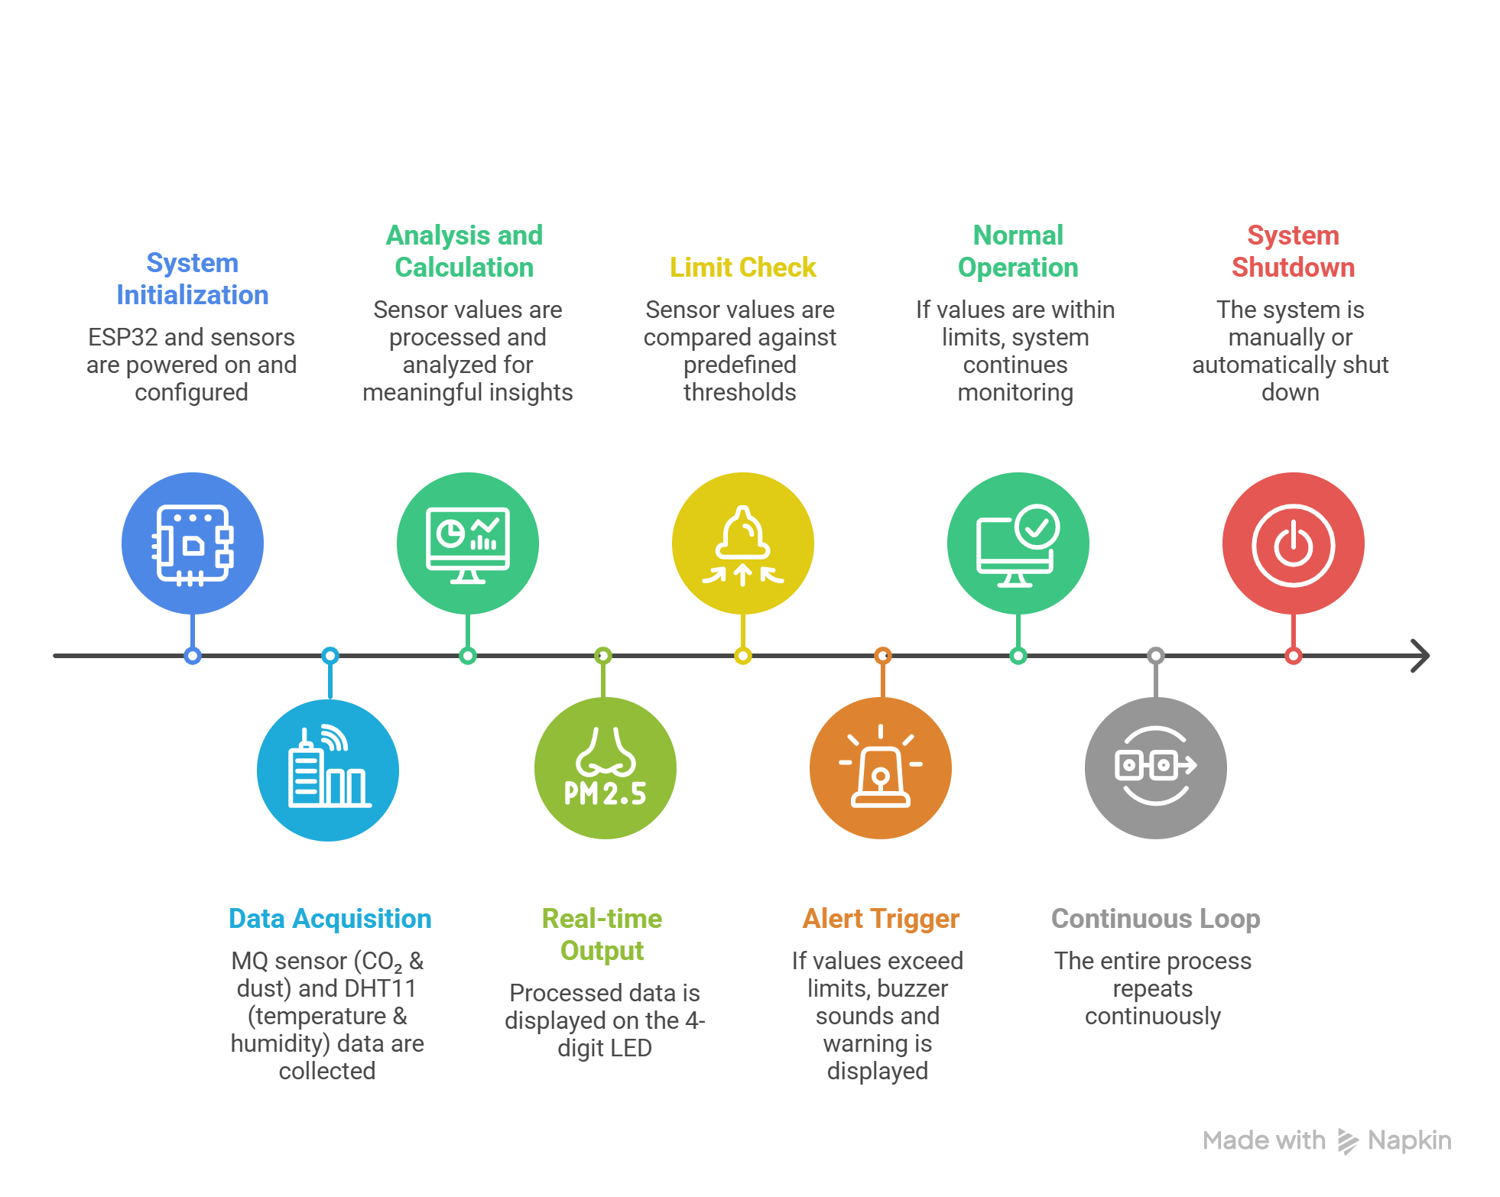

Fig 3.2 shows the flowchart of the system

WORKING

The proposed system works by continuously monitoring environmental parameters using the ESP32 microcontroller as the central processing unit. Initially, all sensors including the MQ2 sensor sensor and DHT11 sensor are initialized. The MQ2 sensor detects the concentration of CO₂ and dust particles in the air, while the DHT11 sensor measures temperature and humidity. These sensor readings are collected by the ESP32 and processed in real time. The processed data is then displayed on a 4 bits LED display, allowing users to easily observe current environmental conditions.

The system continuously compares the sensed values with predefined threshold limits to determine air quality safety levels. If any parameter such as gas concentration, temperature, or humidity exceeds the safe limit, the ESP32 immediately activates a buzzer to alert users about the unsafe condition. At the same time, the warning values are displayed on the 4 bit LED display for quick identification. If all parameters are within safe limits, the system continues normal monitoring without triggering any alert.

This process runs continuously in a loop, ensuring real-time monitoring and quick response to environmental changes. The system is efficient, user-friendly, and suitable for maintaining a safe and healthy environment in indoor spaces such as homes, offices, classrooms, and industrial areas.

IV. SYSTEM REQUIREMENT

HARDWARE REQUIREMENT
- ESP32 Microcontroller
- MQ2 Sensor
- DHT 11 Sensor
- Buzzer
- TM1637 4 Bits LED Display * 4

SOFTWARE REQUIREMENT
- Arduino IDE
- Proteus

V. EXPERIMENTAL SETUP & RESULT

EXPERIMENTAL SETUP

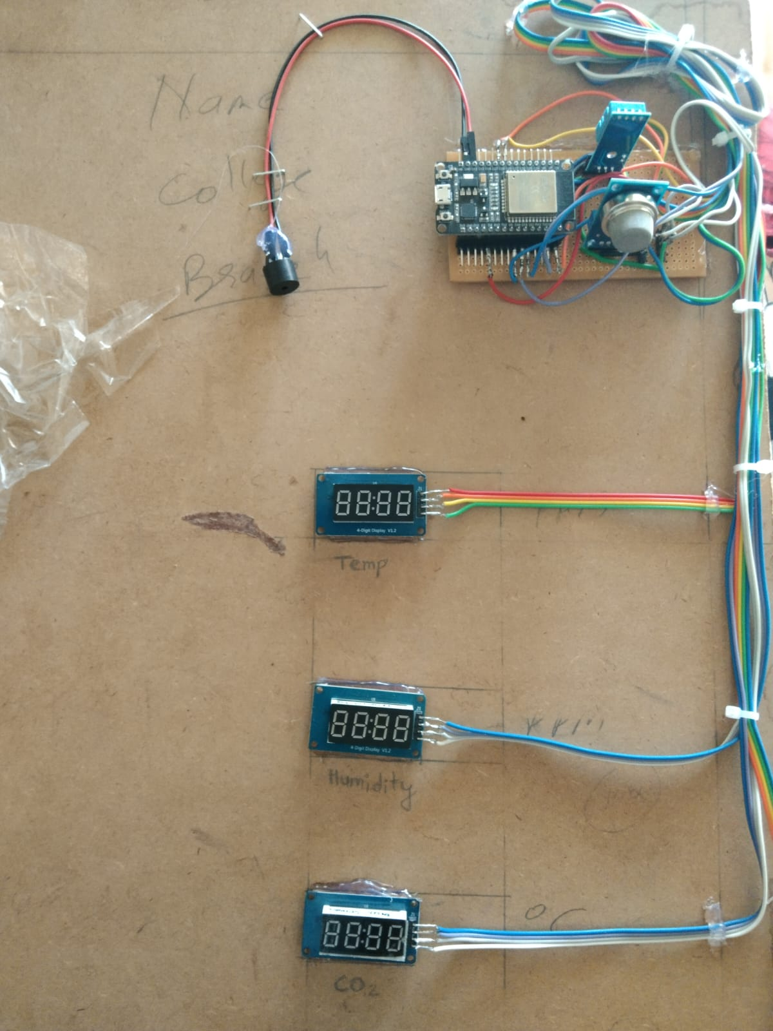
Fig. 2 Shows the Top View of the Proposed System

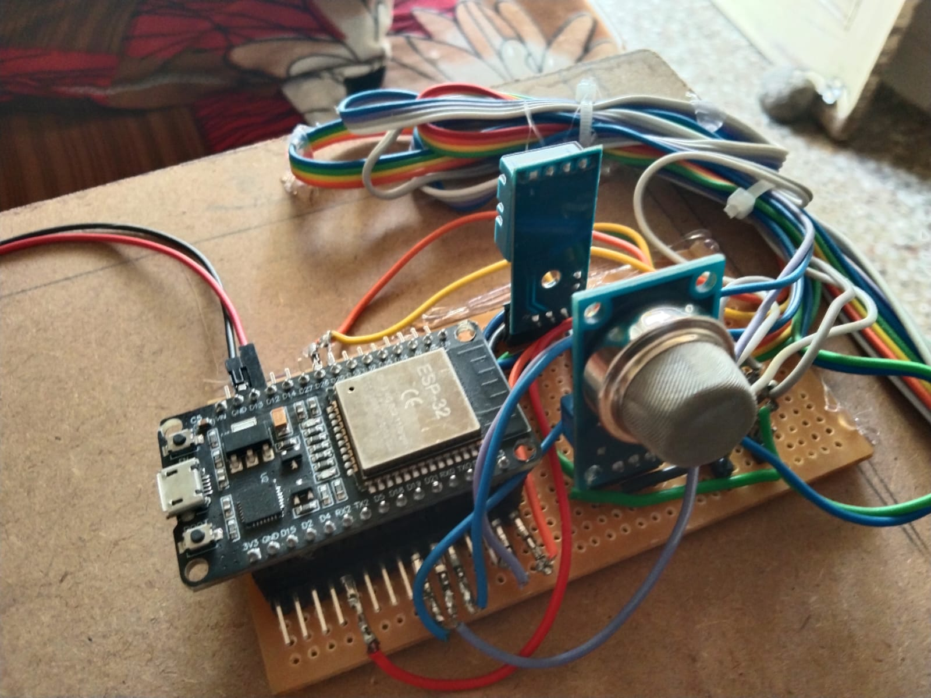
Fig 3 shows the experimental setup of the proposed system

RESULT
The developed Real-Time Environmental Parameters Display system successfully demonstrates the ability to monitor critical environmental parameters, including CO₂ concentration, dust particles, temperature, and humidity, in real time using an ESP 32-based embedded system. During testing, the system consistently captured sensor data accurately and triggered the buzzer alert whenever any parameter crossed its predefined threshold, proving its effectiveness in detecting potentially hazardous conditions. The integration of MQ2 sensors and DHT11 sensors, combined with a simple yet reliable microcontroller platform, ensures low-cost, portable, and efficient operation, making it suitable for a wide range of indoor and industrial applications. The results indicate that the system can significantly enhance environmental safety awareness, enabling timely intervention to protect human health
V. CONCLUSION
The Real-Time Environmental Parameters Display system successfully demonstrates an efficient and reliable method for monitoring critical environmental factors such as CO₂ concentration, dust particles, temperature, and humidity. By integrating ESP32, MQ2 sensors, and DHT11, the system provides accurate, real-time data and triggers a buzzer alert whenever thresholds are exceeded, ensuring timely warning of unsafe conditions. The paper highlights the effectiveness of embedded systems for environmental monitoring, offering a cost-effective, portable, and user-friendly solution. Overall, the system fulfills its objectives by enhancing awareness of environmental conditions, improving safety, and providing a practical platform and advanced predictive features for broader applications in homes, industries, and public spaces.
VI. REFERENCE
      - M. Deepshika, S.Ganesh, M.Vikram, A. Deva Kalyan. “Real Time Air Quality Monitoring System”. Anil Neerukonda Institute Of Technology and Sciences. 2021.
- Thanushree D, Vaishnavi G. “Air Quality Detection using Embedded Systems”. International Journal of Advanced Research in Computer and Communication Engineering Vol. 10, Issue 7, July 2021
- Yeshvant.Ba, Mukesh.P, Yokeswaran.T, Vignesh.S. “Real Time Temperature and Humidity Monitoring System”. Student Journal of Electrical and Electronics Engineering Issue No. 1, Vol. 1, 2022.
- Fatima Khan, Amna Khan, Tariq Ali, Tariq Shahzad, Tehseen Mazhar, Sunawar Khan, Muhammad Adnan Khan, Habib Hamam. “IoT-Driven Pollution Detection System for Indoor and Outdoor Environments”. Tech Science Press. Volume 86, Issue 2, 9 December 2025.
- Osama Alsamrai, Maria D. Redel-Macias and M. P. Dorado. “Real-Time Intelligent Monitoring of Outdoor Air Quality in an Urban Environment Using IoT and Machine Learning Algorithms”. Appl. Sci. 2025.
- 6. Tanishq Kale1, Mary Matilda2 >” Real – Time Industrial Pollution Data Acquisition and Monitoring System using IoT”. International Research Journal of Engineering and Technology Volume: 08 Issue: 09 | Sep 2021
- Manuel Méndez, Mercedes G. Merayo, Manuel Núñez. “Machine learning algorithms to forecast air quality: a survey”. Artificial Intelligence Review (2023).
- Darshini Rajasekar, Aravind Sekar, Magesh Rajasekar. “Air Quality Monitoring and Disease Prediction Using IoT and Machine Learning. International Journal of Innovative Research in Computer Science and Technology. Year: 2020, Volume: 8, Issue: 6
- J. Prayudha, A. Pranata and A. Al Hafiz, “Implementation of fuzzy logic method for air quality measurement system in Medan city based on internet of things (IoT),” JURTEKSI, vol. 4, no. 2, pp. 141-148, 2018.
- N. Middinali and Y. Rahayu, “Development of IoT-based air quality Paper—Real Time System Monitoring and Analysis-Based Internet of Things (IoT) Technology “, Data monitoring system at the University of Riau. JOMFT vol. 6, pp. 1-8, 2019.

